Dear Customer
Vaper Train would like to sincerely apologise for the appearance of the E-liquid labels in your order today.
Our Label printer went down today, and unfortunately we had to make use of labels that had been printed previously.
Meaning the labels on your bottles / order had the wrong nicotine strength / bottle size on them.
Please rest assured that they are the flavour they say they are, but we had to correct the nicotine strength / bottle size over the incorrect label(s) using permanent marker.
This is the first time in over 3 years that we have had to do this, and can only apologise profusely.

Please accept this discount code as way of apology, this will give you 10% of your next order.
VTFB10

Yours sincerely

Vaper Train

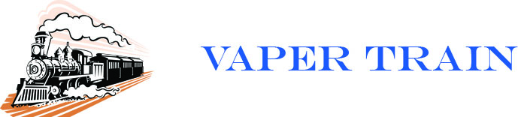

© Vaper Train 2015 http://www.vapertrain.com

